Excel Score-sheets
I would like to describe a number of details Microsoft Excel Score-sheet q0r0-ncd.xlsx. I believe the original Open-Office version was originally created by Jared Haight, and it has been used for score-keeping at the International Quiz Meets. We are using the Excel version, which is nearly identical, with some exceptions. Feel free to use either version.

Features:
The screen should look something like this:
You may need to Enable Editing at the top of the screen.
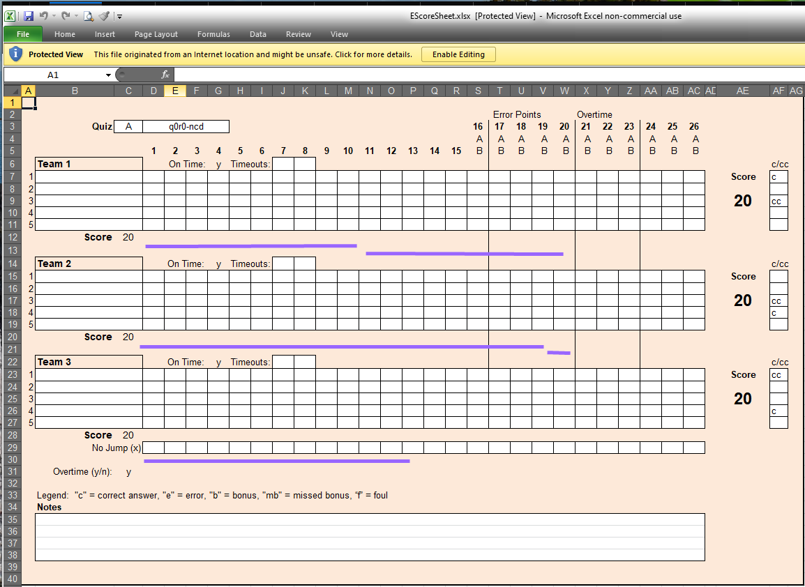
The locations on this page are called “cells”. The name of a cell is the column (a letter) followed by the row (a number). For example, cell C3 contains the letter “A”, indicating that this is an A-division quiz. Some cells are merged, such as Cells D3:G3. I will refer to such a merged cell merely as Cell D3.
In some cells, you will enter values. In the Team name cells, there is a dropdown menu that appears when you click it, and you will need to select from a list of choices. Other cells have equations, and the values are calculated as the quiz progresses. Don’t enter anything in these cells. The white cells in the example above are cells that you can update and/or clear out.

Before the Quiz Starts:
Before a quiz starts, fill out as much information as possible. We will give you some of this information prior to the quiz meet. You will know which “room” you are in, the division for each quiz, the name of each quiz, the time of each quiz, and the teams competing in each quiz. If desired, create a copy of the score-sheet file for each quiz beforehand.
In Cell C3, enter the division. (The only options we will use are A and B, even though other options appear.) In cell D3, enter the quiz ID. This is something like “q1r1-ncd”. This quiz name indicates our quiz 1, room 3, district. You will also use this name for the QuizNet quiz ID. In cells B6, B14 and B22 select the team from the drop-down menu of each cell.
The coach from each team should indicate in the Zoom room chat the names of the quizzers, their seat numbers (if needed), and which is the captain or co-captain. Select the quizzer for each seat from the appropriate drop-down menu. If a seat is empty, and there is a name listed, click on the cell and hit <delete>. Column AF has places to mark captain (C) or co-captain (CC).
If the teams are on time, leave the letter “y” in cells G6, G14 and G22. If they are late, you can choose to enter an “n”. (Be lenient on virtual quizzes. We usually give all of our teams those 20 points.)

During the Quiz:
The score-sheet is similar to the paper score-sheets we have been using. However, rather than entering the score for each quizzer and question, mark each appropriate box with “c” for correct, “e” for error, “b” for bonus, “mb” for missed bonus, and “f” for foul. (These are noted on the legend.) If a question is unanswered, mark an “x” appropriately in cells D29:W29. The spreadsheet will automatically calculate the scores. It will gray out completed questions or questions after an error and mark quizzers who have quizzed out or erred out. The quizzers who have correctly answered questions are automatically marked in column AD.
I added those purple lines to mark questions for which a 5th quizzer is sitting out. To mark these questions, move one of these lines to cover the appropriate cells. Stretch or shrink the line as needed. If you need another line, copy one, move to another cell, paste it, and move it to where it belongs. In a virtual quiz with substitutions, it’s easy to forget where a quizzer is actually “sitting”. This is important when the “corresponding chair rule” for bonus questions is in effect. I suggest marking the new seat in column AD. (This is the same column that marks quizzers who have correctly answered questions.)
If a time-out is called, mark the sheet in cells J6:K6, J14:K14 or J22:K22. Each team has up to 2 time-outs. The quiz-master will place each team in a break-out room for 1 minute.
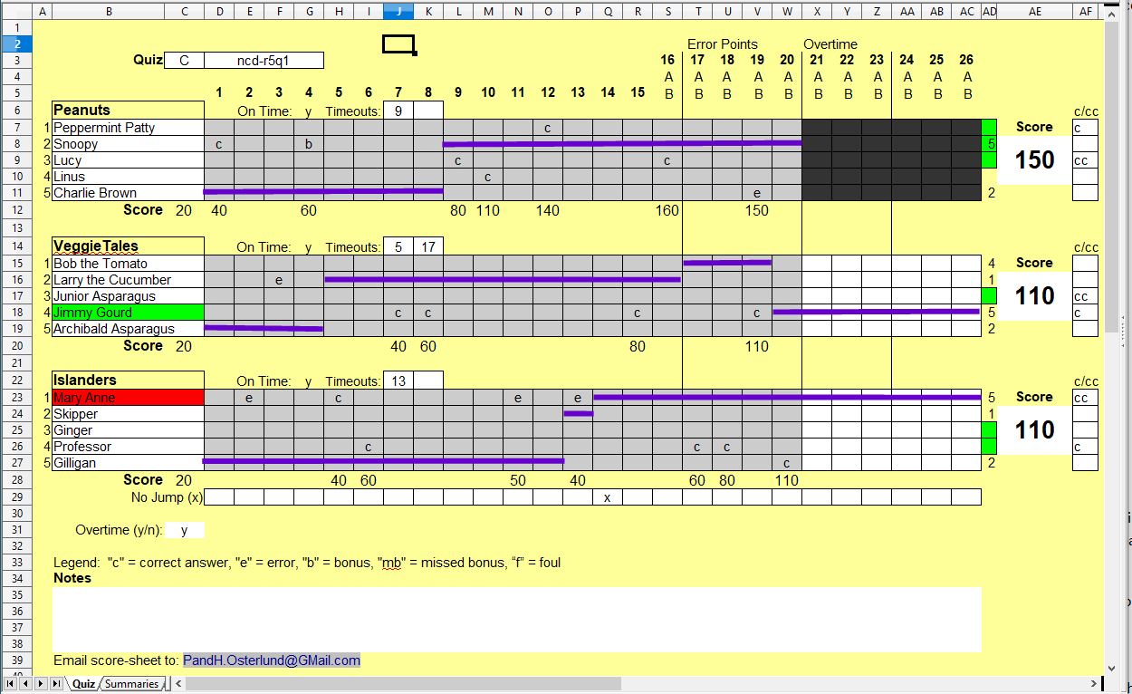
At times, it is appropriate to display the score-sheet over Zoom. These times include when a score-check is requested, upon returning from a time-out, and at the end of the quiz. While the Quiz-master is asking questions, do not display the score-sheet. The Quiz-master needs to be visible over Zoom.
If a tie-breaker is required, place a “y” in cell C31. This will open up 2 overtime sections for scoring. (Beware: The quiz-out and error-out highlighting may not work as expected during overtime.)

After the Quiz:
When the quiz is over, display your score-sheet. A coach from each team will need to compare their score-sheet against yours. When each coach is satisfied with the score-sheet, they will let you know verbally or in a chat message. Mark their agreement in the “Notes” box (Cell B35), along with any other relevant notes. Save the file with the name of the quiz, and e-mail it to the address listed in cell B39.
If you want to clear out the scores, select cells B7:AC11 and press <delete>. Do the same in cells B15:AC19, B23:AC27, D29:AC29, the ‘On Time’ cells (G6, G14, G22), the ‘Timeouts’ cells (J6:K6, J14:K14, J22:K22) and the Error / Overtime cells (S6:AC6, S14:AC14, S22:AC22) as appropriate. Also, move any sit-out purple lines out of the way. Otherwise, start with a clean slate – a copy of the spreadsheet that has not been filled in.

Additional Comments:
The Excel version of this worksheet was done rather quickly. I would not be surprised if there are errors. I copied the equations as closely as I felt necessary from the original Open Office file. If the score-keeping goes astray, enter the correct values where they need to be. (Note that automatic score-keeping requires the “c, e, b, mb, f” values within the quizzer’s rows.)
The score sheet isn’t fool-proof. Don’t score differently on this score-sheet than you would normally on a paper score-sheet, and you should be fine.
The workings behind the scene are on other tabs. During the quiz, only use the tab labeled “Quiz”. I recommend that the other sheets remain unaltered.
If you have any questions or comments, or if you find any bugs, please let me know at PandH.Osterlund@gmail.com.

